update on antibiotic free meat

UW MEDICINE | Food & Nutrition

As a percentage of our food dollars, 92% of dollars spent on pork now goes toward antibiotic free meats.

For poultry, 95% of our food dollars go toward antibiotic free meatUWMC patients can find these antibiotic free meats on our patient center dining menu. All meats served at breakfast are antibiotic free. All of our fresh chicken and pork on our patient menu is raised without antibiotics. Our oven roasted turkey, ground beef used for meatloaf and spaghetti sauce and both our Hamburger & Chicken Burger are from animals raised with no antibiotic or hormones.

At the Plaza Café, we now serve antibiotic free bacon and sausage at breakfast. Our chicken burger, wings & strips are antibiotic free. In addition, you can find meats raised without antibiotics in our whole carving ham, pork chops, pork spare ribs, beef yakisoba, and all fresh chicken entrees, to mention just a few.

**Next steps:** We will continue to pursue items that are of high quality and that were raised sustainably, without the use of non-therapeutic antibiotics, expanding our policy to include Beef in addition to Pork and Poultry.

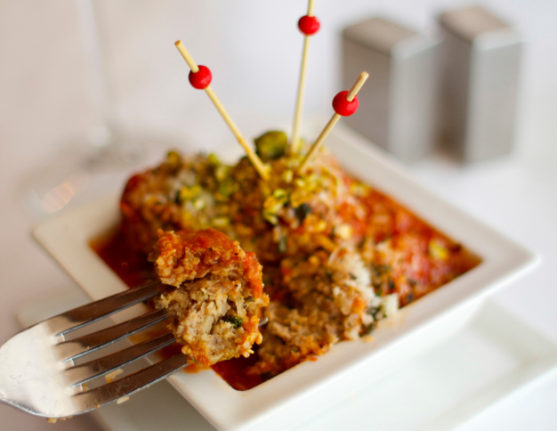

Background: The use of antibiotics in low doses is a practice commonly used in U.S. animal agriculture and this practice can encourage/promote bacteria to become resistant to antibiotics.

Because of the link between antibiotic use in food-producing animals and the occurrence of antibiotic-resistant infections in humans, in April of 2014 the UWMC Food and Nutrition Department instituted a purchasing policy that phases out the purchase of all pork and poultry products that are raised with the use of non-therapeutic antibiotics. Since this time, this policy has expanded to now include all meat products.

This policy aligns with the recommendations of the nation’s scientific community including the CDC, the Food and Drug Administration and World Health Organization and aims to improve the health of the UWMC patients, staff and community.

This document serves as an update to the above purchasing policy and transition away from meats raised with non-therapeutic antibiotics.

Since initiating this policy in 2014, The UWMC food and nutrition department has transitioned 43% of our beef products, 90% of our poultry and 35% of our pork products to those raised without antibiotics. We have targeted our high usage items and as such, have transitioned a high percentage of our food dollars towards meats raised without antibiotics.

UWMedicine_Logo_CMYK.eps